Michael and LiLou’s First Eight Weeks

Where to even begin?! These last 8 weeks have been absolutely incredible! LiLou is growing like a weed. She is 16 weeks old now and weighs 40 pounds. Every time we blink she has grown. She has “giraffe legs” as we like to call them and she has got the goofiest, sweetest, most caring personality with a side of sass and attitude, and we love her to pieces. We like to call her the “tiny tornado” because one minute she is asleep and calm, and the next she is literally bouncing off the walls. George (our English bulldog) and LiLou are best buddies as long as she isn’t biting at his face with her razor puppy teeth. They love to snuggle though! LiLou’s favorite things to do are playing and training with her dad, playing with other dogs, running, tug of war, playing in water, eating and snuggling. The bond that Michael and LiLou have is already so strong and they are inseparable. It is so neat to watch her somewhat “panic” if she doesn’t know where he went. So, Michael likes to play hide and seek with her and she finds him quicker than he can hide.

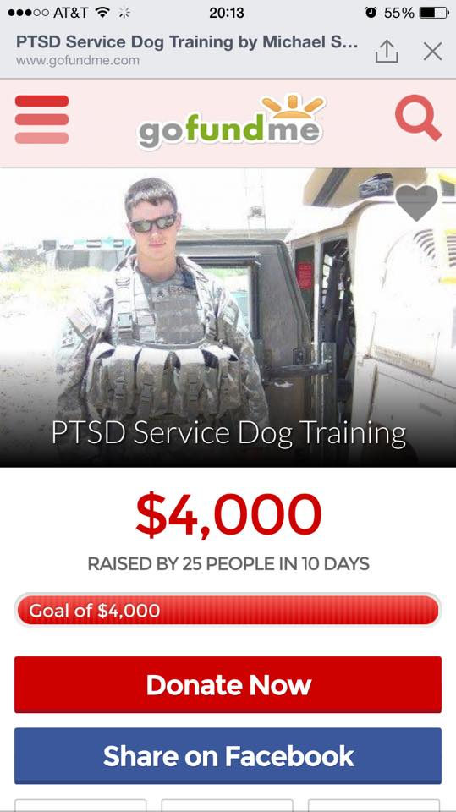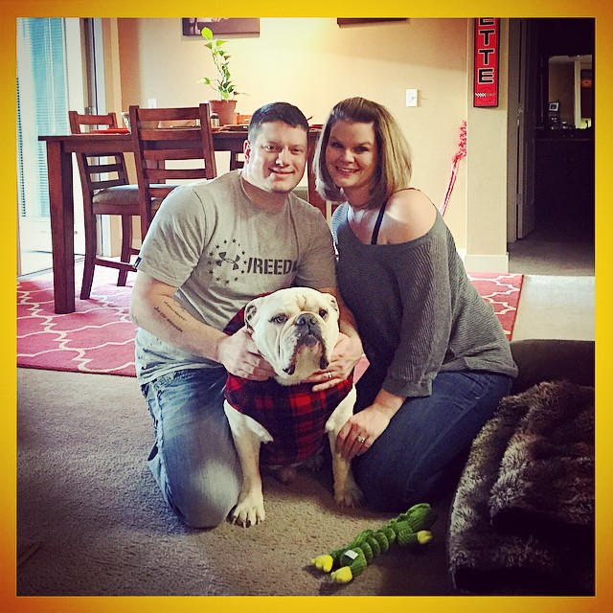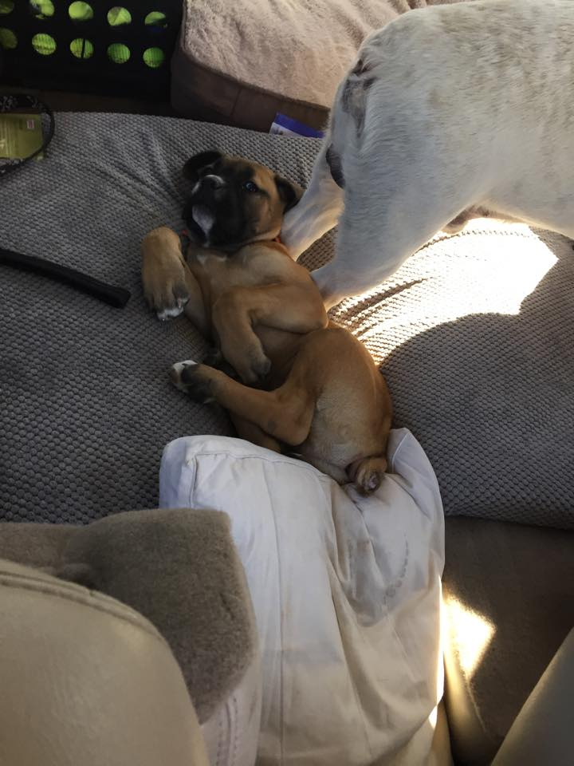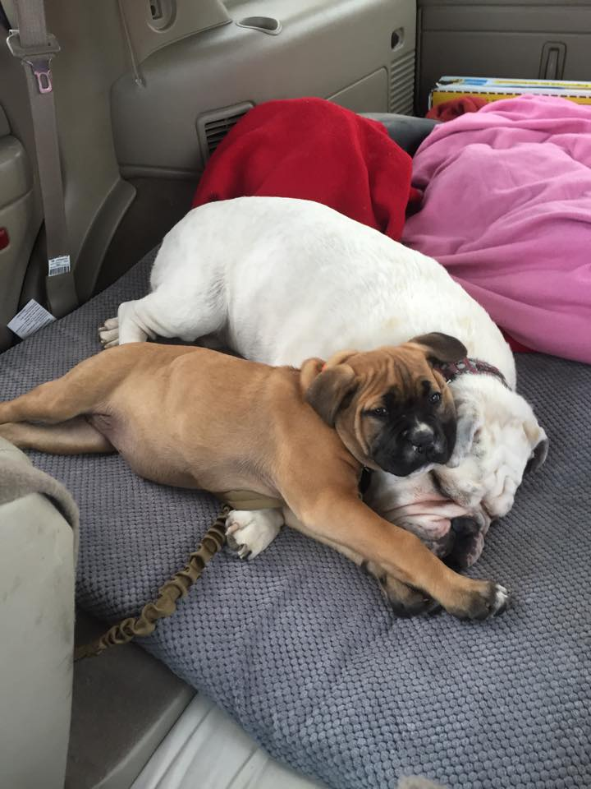

As far as training goes, we will start from the very beginning. The training started from the minute we brought her home. Right now we are focused on getting all the basics down; meaning potty training, sit, stay, lay down, come, learning her name etc. Michael wanted to train LiLou in both English and Italian so she is learning both forms of each command.

Week One: This was the biggest struggle. We were all trying to get adjusted to one another after being on the road for 5 long days. LiLou of course slept a lot until it was the proper time to sleep (night time) so we had a long week of her waking up at all hours of the night. She slept on her bed that Cody’s Cause bought her in her play pen (she was not into being in her crate quite yet) and she did pretty good as far as waking up to go potty but sometimes we didn’t get to her quick enough. To be totally honest we had a moment of “Oh my gosh, what in the world did we do and why did we get a puppy?!” We were in somewhat of a panic, but this is where Matt Wilson and Jumoke Johnson (our trainers at Alpha Fit K9) talked us down and gave us some reassurance. After we got our feet planted back on the ground and got some rest everything started to fall into place.

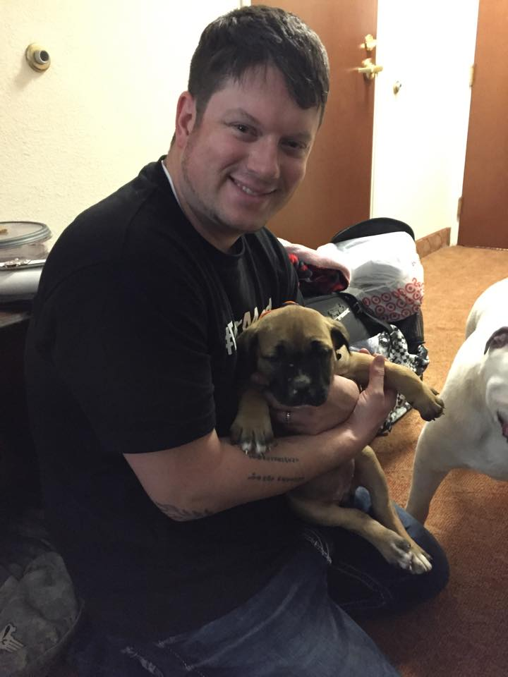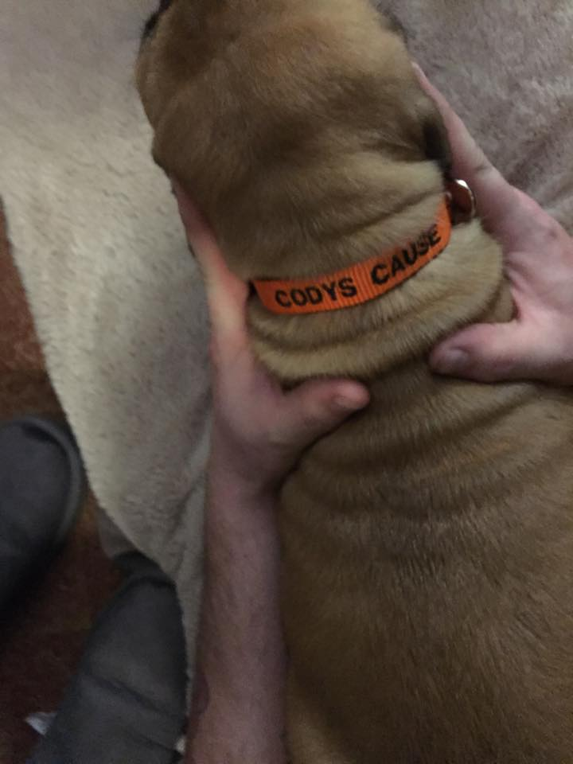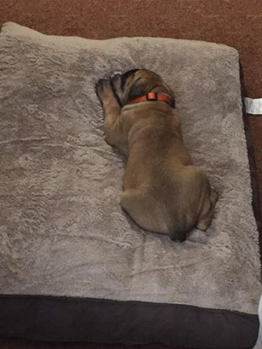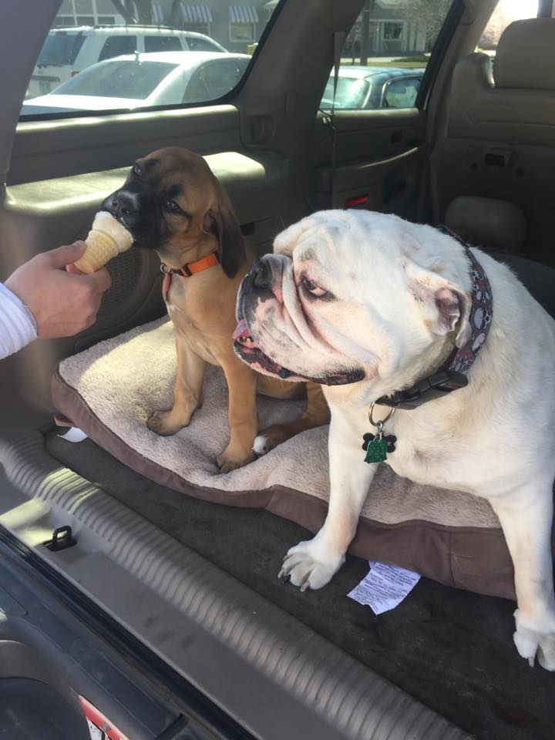

Week Two thru Four: These were the weeks that we had some victories and some defeat. LiLou was very quick to be fully potty trained. We actually ended up getting her a grass pad and put it out on the balcony and she goes and kicks open the door and takes herself out now. We live on the third floor, as of right now, so taking LiLou down the stairs every hour (it seemed) was not agreeing with Michael’s back. Matt comes up about once a week to give Michael new tasks, usually three at a time, that he then has to work on with LiLou for 15-20 minutes at a time, 3 times a day. Matt made Michael a “flirt stick” which has a toy on the end of a string that is attached to a pole, which they use for training. They use that to teach her agility and being quick on her feet, as well as how to capture a moving object and to learn to latch onto an object while being distracted, such as having her eyes covered, being touched, noises made etc. so she learns that it is alright to hold her grip with all the distractions and not to release until she is told to. Getting her to recognize her name instead of the sounds we were making to get her to come was a hard habit for us to break, but we have successfully done it and she knows her name officially!

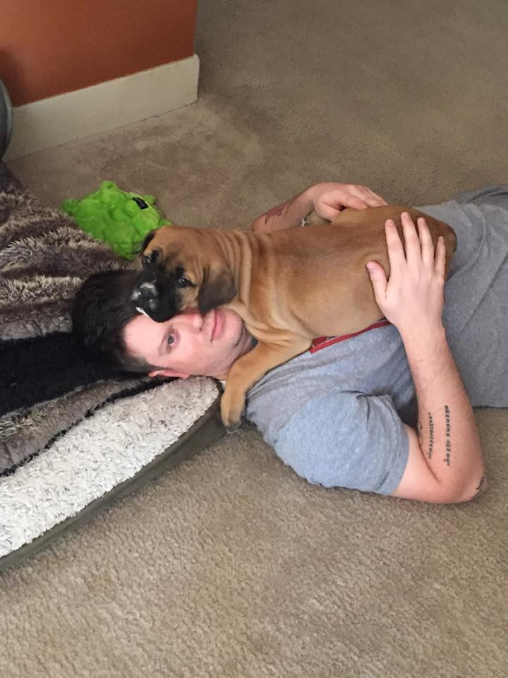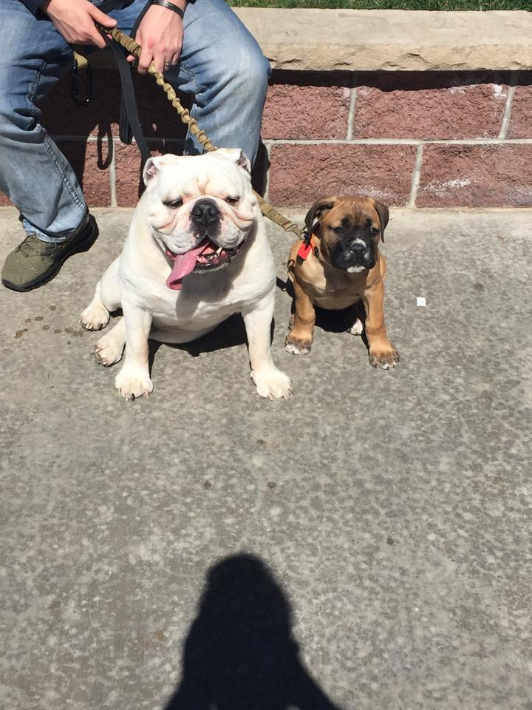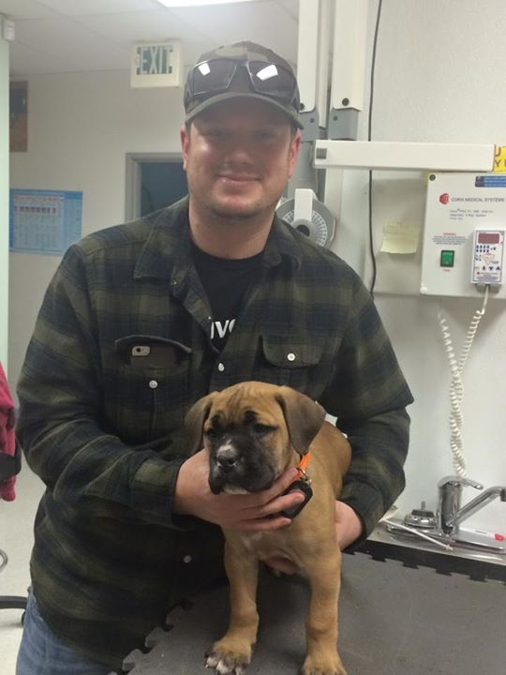

Week Five Thru Seven: Michael has continued to do his training that Matt has wanted him to work on. They have accomplished, in both English and Italian: sit, stay, lie down, come, and leave it. Granted it is a work in progress and she will continuously be training in basic commands so that she is extremely tentative to everything that Michael says and does. They have also been working on getting LiLou to sit and stay on high awkward objects. This is to get her to be comfortable in uncomfortable situations along with working on her balance and agility. Michael finally got to take LiLou on her first trip out in public! We took her to Target and she did AWESOME! She continues to go more and more places with Michael and both of them love it. She has been not only to Target, but also many other grocery stores as well as to the doctor’s office a few times. She loves getting to wear her vest. One thing we have found to be somewhat frustrating is that people’s first instinct when we are in public is to want to pet her and talk to her in “baby talk” and it makes her very excited and then that stresses Michael out since people are coming up from nowhere and surprising both of them. So, at this point I still make sure that I am watching to try and get most people to steer clear of them. We are going to be getting a “Do Not Pet” tab to go on her vest.

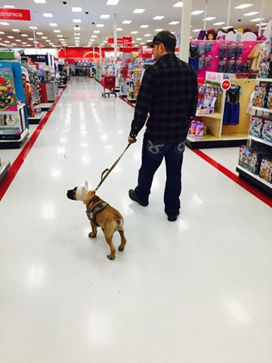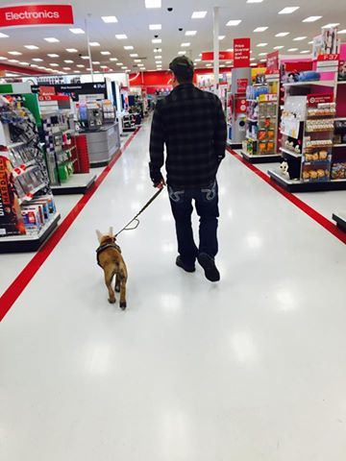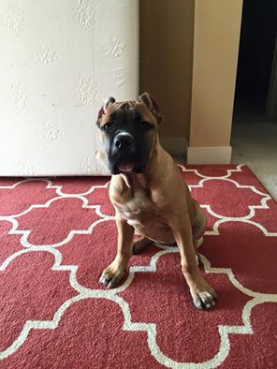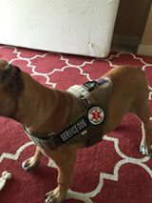

Week Eight: LiLou went in for her vet checkup today and got a few more shots and weighed in at 40.4 pounds! She is gaining about 10-12 pounds every month so far. She is going to be one big girl! She sleeps in the bed with us, which is all right for the moment but as she grows we are going to have to get a bigger bed. She sleeps with her head up on the pillow just like a little person, smack dab in the middle of us and has even started to wake Michael up somewhat during his nightmares. She loves being in the car but feels the need to be up front and center to make sure she can see anything and everything, so we are working on her staying in the back of the car. Matt is still coming up once a week to work with Michael and LiLou and he will be her on Friday, so I will have more training updates then!

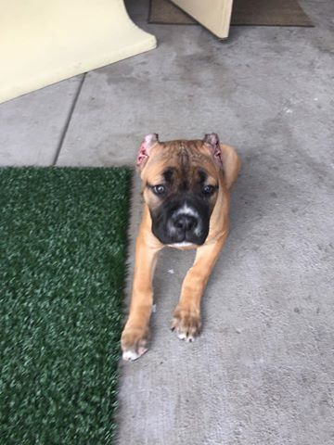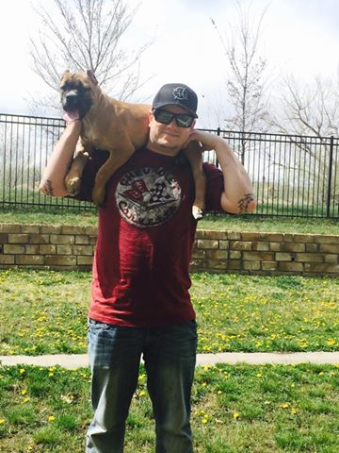

This has been such an incredible first 8 weeks and it seems like we have had this little girl forever and she has become part of the family in a big way. I love seeing the smile on Michael’s face in the morning when he wakes up and the attention that he pays to her and making sure that she is fed and taken care of. They have gotten into their own routine, which is great. It has really made an impact on his attitude when it comes to having patience and taking care of something else. Patience has been something that both of us have to keep working on because there are legitimate frustrations every day. We are claiming LiLou is in her toddler years now, so she has moments where you would think she has never learned a thing in her life and is wild. Then there are the times where everything just clicks for her and Michael gets so excited and you can see the pure joy the two of them are experiencing together.

We appreciate all the love and support from everyone and we could not have done any of this without the help from Cody’s Cause and the training from Matt and Jumoke at Alpha Fit K9. We will never be able to express how appreciative we truly are. THANK YOU for making this all possible!

Love,

Michael, Arianna, LiLou, and George

